**Level 1: PC Tower Case**

**Outline**

Learn about the internals of a standard PC case by examining physical samples and selecting and labeling images found on-line. Gain deeper knowledge by researching and reporting on specific components.

**Questions**

1. Find one (or more) images that clearly show the internals of a PC Tower Case.   
   (i.e. Google images using keywords “PC Case Internals”)

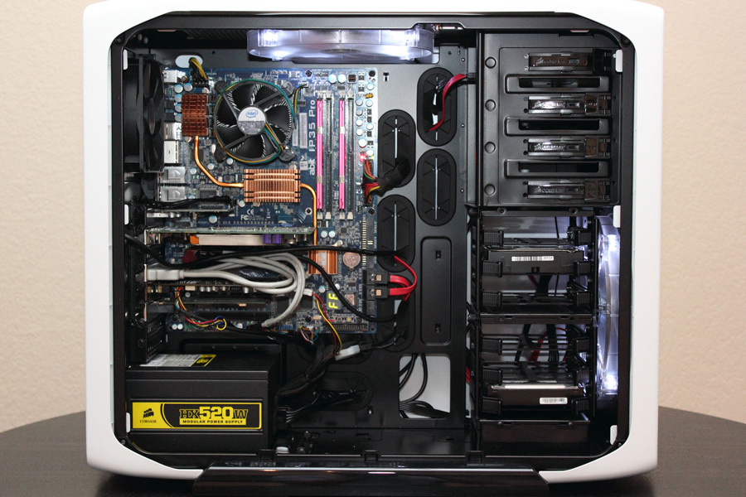

1. Clearly label the following components (using arrows) on your image of the PC case internals:
   1. Motherboard
   2. Power Supply
   3. Hard Disk Drive
   4. Optical Disk Drive (e.g.DVD)
   5. USB Expansion Ports
   6. Monitor Port
   7. Audio Ports
   8. Ethernet Port
   9. Cooling Fan

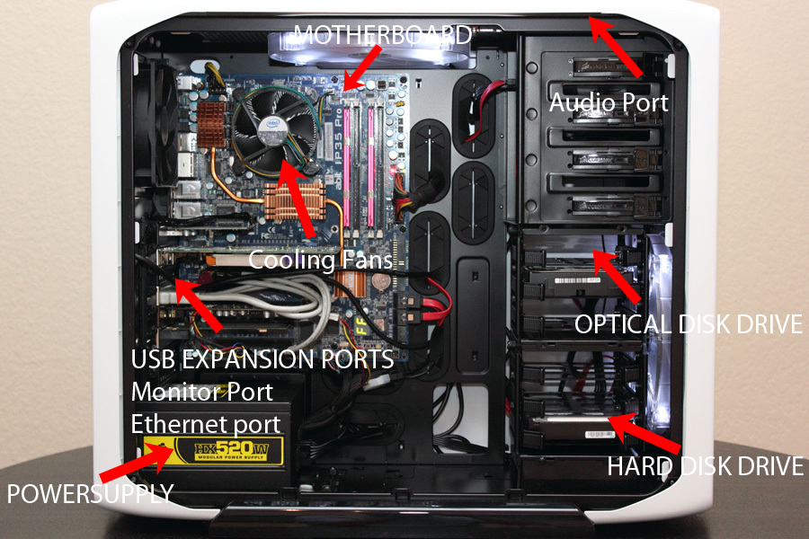

1. Research more in-depth about “Motherboards”. Make notes on the following:
   1. What different versions are currently available (speed and capacity)
   2. How the component has changed since the 1980’s

Types of Motherboards. Motherboards come in different sizes, known as form factors. The most common motherboard form factor is ATX. The different types of ATX are known as micro-ATX.

1. Research more in-depth about “Hard Disk Drives”. Make notes on the following:
   1. What different versions are currently available (speed and capacity)
   2. How the component has changed since the 1980’s

The IBM 350 Disk File was developed under the code-name RAMAC by an IBM.

It was announced in 1956 with the then new IBM 305 RAMAC computer. The IBM 350 drive had fifty 24-inch (0.6 m) platters, with a total capacity of five million 6-bit characters (3.75 megabytes).

**Level 2: PC Motherboard**

**Outline**

Learn about the structure of a standard PC motherboard by examining physical samples and selecting and labeling images found on-line. Gain deeper knowledge by researching and reporting on specific components.

**Questions**

1. Find one (or more) images that clearly show the layout of a PC Motherboard.   
   (i.e. Google images using keywords “PC Motherboard”)
2. Clearly label the following components (using arrows) on your image of the PC motherboard:
   1. CPU (and fan)
   2. RAM Memory
   3. Disk Drive Interface (IDE or SATA)
   4. GPU Graphics Processor (either on-board or Graphics Card)
   5. Sound Processor (either on-board or Sound Card)
   6. Wi-Fi / Ethernet Network Interface (either on-board or Graphics Card)

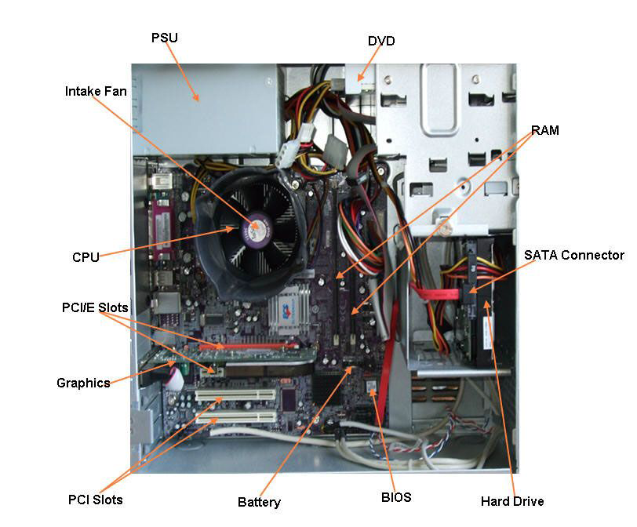

1. Research more in-depth about “CPU Processor Chip”. Make notes on the following:
   1. What different versions are currently available (speed and capacity)
   2. How the component has changed since the 1980’s

Different Versions:

AMD RYZEN 7 2700X

AMD RYZEN THREADRIPEER 2950X

Intel core i5-8600k

INTEL CORE I7-7820X

For one thing, chips have wider registers and can address more memory. In the 80s, you might have used an 8-Bit CPU, but now you almost certainly have a 64-bit CPU in your machine.

1. Research more in-depth about “RAM Memory”. Make notes on the following:
   1. What different versions are currently available (speed and capacity)
   2. How the component has changed since the 1980’s

Different Versions:

Corsair Vengeance LED

G.SKILL TRIDENT Z RGB

HYPERX PREDATOR

KINGSTON HYPERX FURY

Nowadays we are used to having hundreds of gigabytes of storage capacity in our computers. Even tiny MP3 players and other handheld devices usually have several gigabytes of storage.

**Level 3: Peripheral Devices**

**Outline**

Learn about how peripheral devices are connected to the back side of a typical PC tower case. Examine physical samples, select and labeling images found on-line and gain deeper knowledge by researching and reporting on specific components.

**Questions**

1. Find one (or more) images that clearly show the layout of the back of a typical PC tower case.   
   (i.e. Google images using keywords “Back Of PC Tower”)
2. Clearly label the following components (using arrows) on your image of the back of a typical PC tower case:
   1. Power cord and power switch
   2. Monitor Interface (VGA or DVI or HDMI)
   3. Mouse Interface (USB or PS/2)
   4. Keyboard Interface (USB or PS/2)
   5. USB Ports
   6. Audio Inputs / Outputs
   7. Ethernet Interface

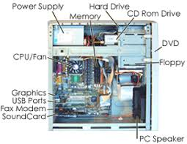

1. Research more in-depth about “Monitor Technology”. Make notes on the following:
   1. What different versions are currently available (e.g. VGA / DVI, Flat Panel Technology))
   2. How the component has changed since the 1980’s (e.g. Display Resolution, Technology)

ACER PREDATOR XB272

ASUS ROG PG258Q

AOC AGON AG251FG

DELL ALIENWARE AW2518H

Back then the display resolution on a monitor was trash, you had a hard time seeing and the resolution was pretty bad. Today we have wide gaming monitors that are ultra 4k and they have the best resolution and very fast response time.

1. Research more in-depth about “External Portable Storage”. Make notes on the following:
   1. Floppy Disks
   2. CD-ROM / DVD / Recordable CD/DVD
   3. USB Memory Drives
   4. Compact Flash Memory
   5. Cloud Based Storage

Nowadays we are used to having hundreds of gigabytes of storage capacity in our computers. Even tiny MP3 players and other handheld devices usually have several gigabytes of storage.

For one thing, chips have wider registers and can address more memory. In the 80s, you might have used an 8-Bit CPU, but now you almost certainly have a 64-bit CPU in your machine.

**Level 4: PC Component Presentation**

**Outline**

Explore the development and features of a specific PC hardware component through deeper research and investigation. Work in partners to create a short presentation. Deliver the presentation to the class.

Each group will research a unique PC hardware component . Your specific topic will be assigned from the list provided below.

**Presentation Structure**

1. Explain what the PC component does and how it fits together with other components to make up a fully functioning PC.
2. Explain how the PC component works. Provide a diagram (image) showing the main parts of the component.
3. Research the current state of the art of the component in terms speed, capacity (size), and other related factors.
4. Research on-line suppliers that sell the PC Component. List the specifications for the available products and the cost (price).
5. Research how the PC component has changed and evolved since the early days of PCs in the 1980’s. Cover each of the following topics separately:
   1. Component Speed
   2. Component Size / Capacity
   3. Two other specifications specific to the PC component (ask Mr. Nestor)

**PC Component Topics**

|  |  |  |
| --- | --- | --- |
| **Topic** | **Partner 1** | **Partner 2** |
| CPU Microprocessor Chip |  |  |
| Motherboard Layout |  |  |
| Computer Graphics |  |  |
| Sound & Audio |  |  |
| Hard Disk Drives |  |  |
| Removable Disk Storage |  |  |
| Network / Internet Connectivity |  |  |
| Mouse / Pointing Devices |  |  |
| Monitor & Display Technology |  |  |
| Printers & Output Technology |  |  |